Name : yogesh dinesh joshi
Sap id : 590025632
Batch : 34

Experiment 1: Python Installation and Basic Python Statements

Objective 1 : installation of python and understanding scripting and interactive modes in IDLE

Objective 2 : create a variable to store your age and its type
Code : 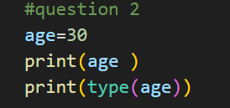
Output : 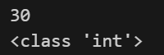

Objective 3 : declare a string variable and assign it a value
Code : 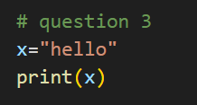
Output : 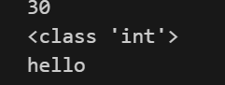
Objective 4 : take different type of data type and print the values using print function
Code : 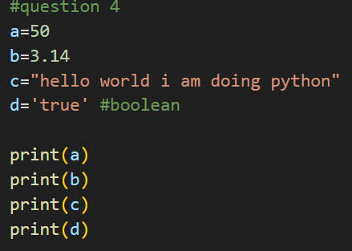
Output : 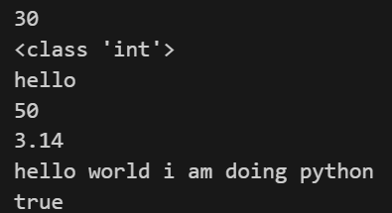
Objective 5: declare two variable and do all the arthimetic operations
Code : 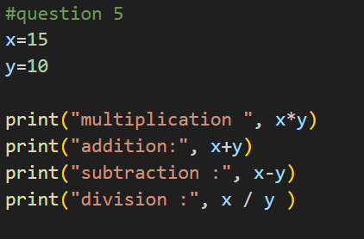
Output : 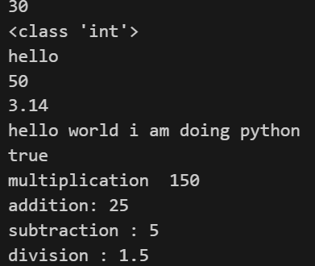

Objective 6: compute hypotenuse
Code : 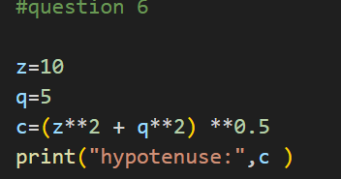
Output : 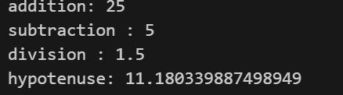

Objective 7: find the simple interest
Code : 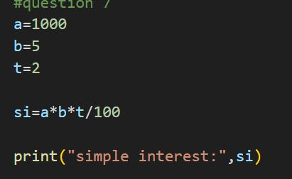
Output : 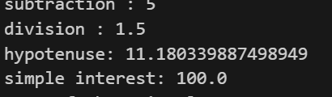

Objective 8 : find the area of the triangle
Code : 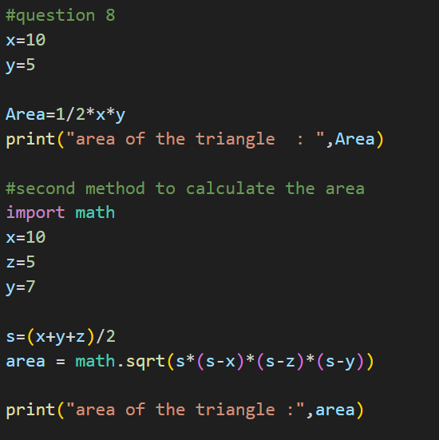
Output : 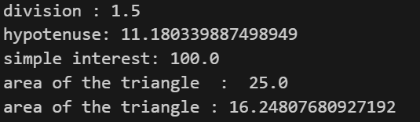

Objective 9: covert to give second into hours , minutes and remaining time
Code : 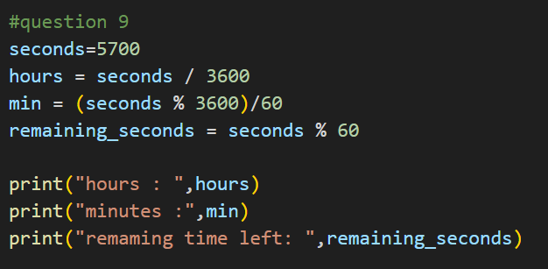
Output : 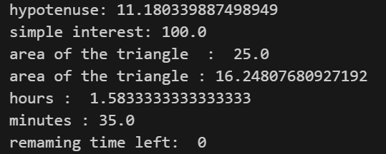

Objective 10 : replace the number
Code 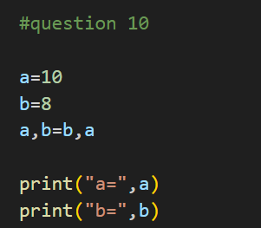
Output : 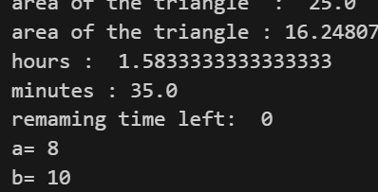
Objective 11: find the sum of first n natural number
Code : 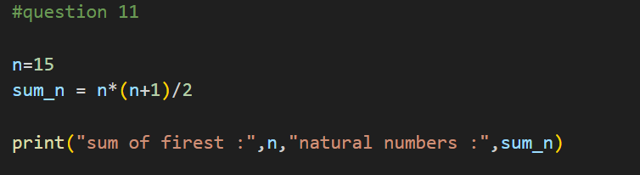
Output : 